The 2013 Bon Appetit Food Lover's Cleanse
(All recipe servings are for 4 unless otherwise specified)
http://www.bonappetit.com/uncategorized/article/day-1-of-the-2013-food-lover-s-cleanse#lunch
Day 1 2
Day 2 9
Day 3 14
Day 4 19
Day 5 24
Day 6 28
Day 7 33
Day 8 38
Day 9 43
Day 10 47
Day 11 52
Day 12 57
Day 13 62
Day 14 66

Day 1

Breakfast

Pomegranate-Walnut Oatmeal
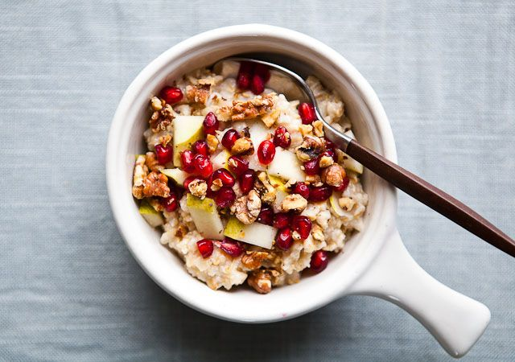
Cook oatmeal made with ½ cup dried old-fashioned oats (or ¼ cup steel-cut oats) according to package directions; top with ½ cup chopped fruit and 1 Tbsp. each chopped toasted walnuts and pomegranate seeds.

Lunch

Kale Salad with Tuna and White Beans
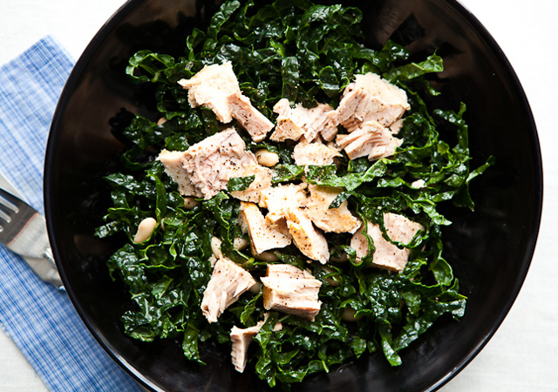
Toss 3 oz. canned water-packed albacore tuna with ¾ cup drained white beans and 4 cups slivered kale (we prefer Tuscan kale). Toss with 1½ Tbsp. Sherry Vinaigrette.
If you can’t find the kale, spinach is a good substitute.

Sherry Vinaigrette
Makes ¾ cup
- 1 medium shallot, minced
- 2 tablespoons Sherry vinegar
- 1 tablespoon fresh lemon juice
- 1 teaspoon Dijon mustard
- 9 tablespoons extra-virgin olive oil
- Fine sea salt and freshly ground black pepper
Stir shallot, vinegar, lemon juice, and mustard in a small bowl and let macerate for at least 15 minutes. Gradually whisk in oil (or stir first 4 ingredients in a jar with a lid, add oil, screw on lid, and shake to combine). Season to taste with salt and pepper.
DO AHEAD: Cover and chill in an airtight container for up to 1 week. To freshen the flavour of the dressing after a few days, add a squeeze of fresh lime or lemon juice.

Snack

Apple-Blackberry Smoothie
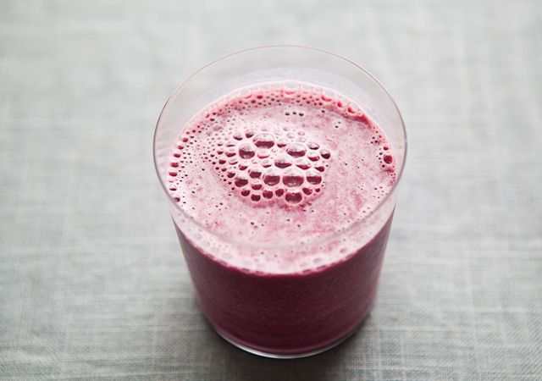
Combine ¾ cup apple cider, ½ cup frozen blackberries, and &frac13; cup Greek yogurt in a blender; purée until smooth.

Dinner

Black Cod with Swiss Chard, Olives, and Lemon

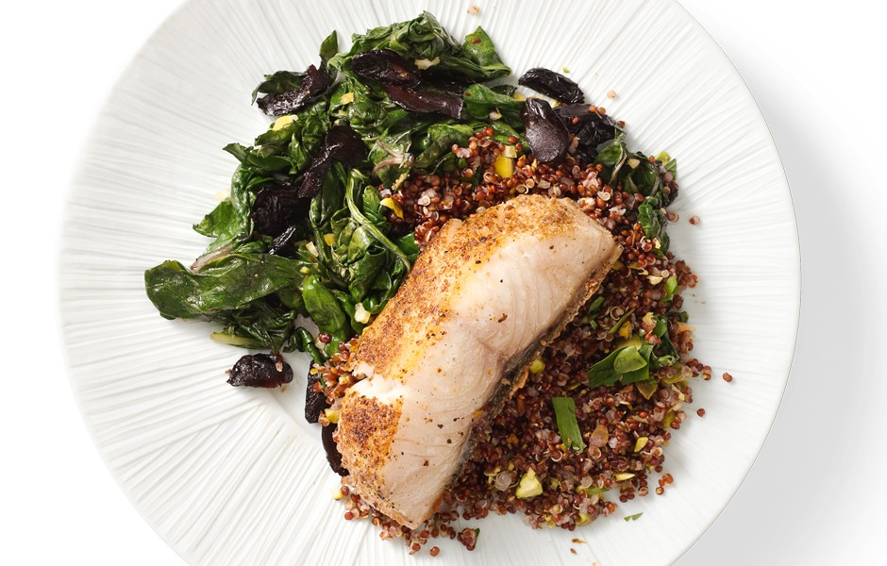
- 1 lemon, stem removed
- ¼ teaspoon coriander seeds
- ¼ teaspoon cumin seeds
- 2 tablespoons olive oil, divided
- 44-ounce pieces skin-on black cod fillet
- Kosher salt and freshly ground black pepper
- 1 garlic clove, chopped
- ¼ teaspoon (or more) crushed red pepper flakes
- 2 large bunches Swiss chard (about 1 1/2 pound total), ribs and stems removed, leaves torn
- 2 tablespoons oil-cured black olives, pitted, sliced
Special Equipment: A spice mill (optional)
Place lemon in a small saucepan; add water just to cover. Place a small heatproof plate inside the saucepan, on top of the lemon, to keep it submerged. Bring water to a boil; reduce heat and simmer until lemon is very tender when pierced with a knife, about 30 minutes. Drain. Cut lemon in half (to help cool faster); let cool.
Scoop out pulp from both lemon halves and press pulp through a coarse-mesh sieve into a small bowl; discard solids. Finely chop peel and pith and add to pulp. Set aside.
Toast coriander and cumin seeds in a small skillet over medium heat, stirring often, until slightly darkened and fragrant, about 3 minutes. Set aside.
Coarsely grind coriander and cumin seeds in spice mill or with mortar and pestle. Heat 1 tablespoon oil in a large nonstick skillet over medium-high heat. Season fish with spice mixture, salt, and pepper; place skin side down in skillet. Cook until browned and crisp, 5-6 minutes. Turn; cook until just opaque in the center, 2-4 minutes more.
Meanwhile, heat remaining 1 tablespoon oil in a large skillet over medium heat. Add garlic and ¼ teaspoon crushed red pepper flakes; cook, stirring, until fragrant, about 30 seconds. Add chard by the handful, tossing and allowing it to wilt slightly between additions. Season with salt and pepper. Cook, tossing occasionally, until all chard is tender, 5-7 minutes. Set aside.
Mix olives and reserved lemon mixture into chard. Season with salt, pepper, and more crushed red pepper flakes, if desired. Serve fish with chard.

Red Quinoa with Pistachios
- 1 tablespoon olive oil
- 1 shallot, finely chopped
- Kosher salt and freshly ground black pepper
- 1 cup quinoa, preferably red, rinsed well in a fine-mesh sieve
- 1 1/2 cups low-sodium chicken broth or water
- ¼ cup unsalted, shelled raw pistachios, chopped
- 3 tablespoons chopped flat-leaf parsley
- 1 tablespoon chopped fresh mint
Heat oil in a medium saucepan over medium heat. Add shallot, season with salt and pepper, and cook, stirring occasionally, until soft, about 5 minutes. Add quinoa and cook, stirring frequently, until quinoa starts to toast and smell nutty, about 5 minutes. Add chicken broth and bring to a boil.
Stir in quinoa, reduce heat to low, cover, and simmer gently until quinoa is tender, 25-30 minutes (15 if using white quinoa). Remove pan from heat, fluff quinoa with a fork. Cover; let stand for 5 minutes.
Fold pistachios, parsley, and mint into quinoa. Season with salt and pepper.

Dessert

Salted, Seedy Chocolate Bark

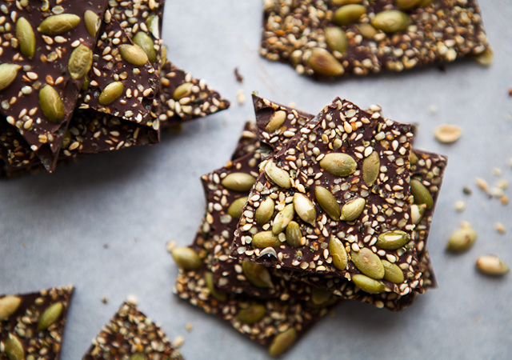
- 1/4 cup raw shelled pumpkin seeds (pepitas)
- 2 tablespoons hemp seeds
- 2 tablespoons sesame seeds
- ¼ teaspoon flaky sea salt or kosher salt
- 8 ounces chopped bittersweet chocolate (at least 70% cacao)
Heat a dry skillet over medium-high heat; add pepitas. Toast, stirring occasionally, until the pumpkin seeds first start to pop, about 1 minute. Pour seeds into a bowl. Toast hemp seeds in the same skillet over medium-high heat, stirring frequently, until fragrant and just starting to turn a pale straw gold, about 45 seconds. Add to bowl with pepitas. Toast sesame seeds in the same skillet over medium-high heat until fragrant and just starting to turn golden, about 45 seconds. Add to bowl with other seeds. Add salt; toss to combine.
Place chocolate in a microwave-safe bowl. Microwave at 50% power for 1 minute. Stir; continue cooking in 30-second bursts, stirring after each, until chocolate is melted.
Pour melted chocolate onto a parchment paper–lined baking sheet; smooth out into a thin even layer (it will not cover the entire sheet pan). Evenly sprinkle seed mixture over chocolate. Let stand at room temperature until set, 2 hours or more. Break into 8 pieces (chocolate may be soft, depending on brand used). Store airtight in refrigerator. Let stand at room temperature for 10 minutes, if desired, before eating.

Day 2

Breakfast

Raspberry-Hazelnut Muesli
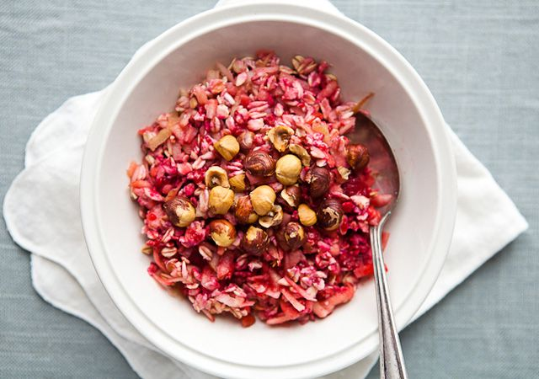
Muesli is a cold porridge of fruit, nuts, and oats that you prepare the night before serving. In this case, the juices of clementines and frozen raspberries are blended with yogurt to make a soft pudding, which gets some toothsome texture the next morning from bits of toasted hazelnuts.
In a small bowl, mix:
- ½ cup frozen raspberries,
- ½ cup old-fashioned oats,
- &frac13; cup unsweetened nonfat yogurt
- ½ of a large apple (skin on, cored, shredded)
- fresh-squeezed juice of 1 clementine or ½ of a navel orange
- a pinch of salt
Cover and chill overnight. In the morning, sprinkle 1 Tbsp. chopped toasted hazelnuts over.

Lunch

Pistachio Quinoa with Spinach and Egg
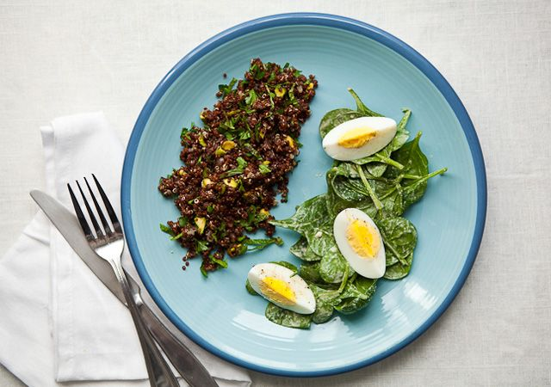
Toss 4 cups spinach with 1½ Tbsp. Smoky Lemon Tahini Dressing (see below).
Top with 1 hard-boiled egg cut into wedges.
Serve alongside 1 cup leftover Pistachio Quinoa at room temperature, with an extra squeeze of lemon juice mixed in, if you like. If you don’t have leftovers, substitute chickpeas or brown rice.

Smoky Lemon Tahini Dressing
Makes 1½ cups
- 1 garlic clove, grated
- ½ cup tahini (sesame seed paste)
- ¼ cup fresh lemon juice
- ¾ teaspoon kosher salt
- 1/8 teaspoon smoked paprika
Purée garlic, tahini, lemon juice, salt, paprika, and 3/4 cup water in a blender until smooth, adding water if needed to thin dressing.

Snack

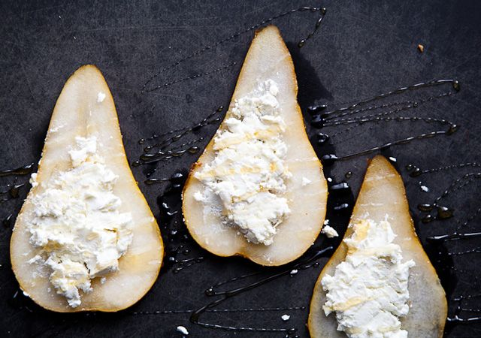

Bosc Pear with Fresh Goat Cheese and Honey
Thinly slice 1 Bosc pear. Spread 1 oz. goat cheese, divided, on pear slices; drizzle with ½ tsp. honey.

Dinner

Butternut Squash-Shiitake Ragout
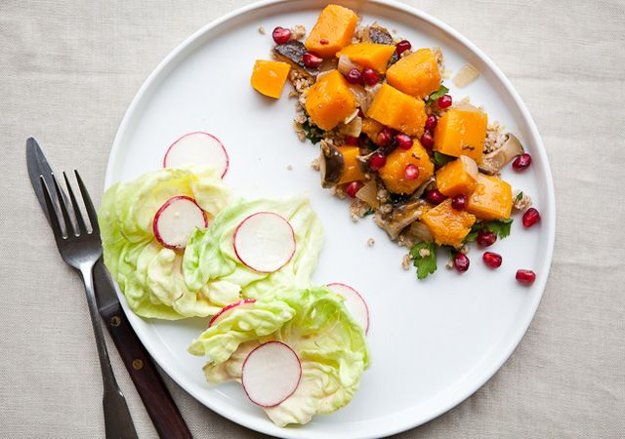
Makes 6 cups. Click link for original
- 10 ounces fresh shiitake mushrooms, stems removed and reserved, chopped
- 4 sun-dried tomatoes, not packed in oil (optional)
- 2 tablespoons olive oil
- Kosher salt
- 1 garlic clove, finely chopped
- ½ cup tawny Port, divided
- 1 large onion, chopped
- 1 medium butternut squash, peeled, seeded, cut in 1” cubes
- ¼ cup pomegranate seeds
Combine shiitake stems, sun-dried tomatoes, if using, and 2 cups boiling water in a medium bowl. Let stand for 15 minutes.
Heat oil in a large heavy skillet over medium-high heat. Add mushroom caps; cook until lightly colored, about 2 minutes. Stir in a pinch of salt; the mushrooms will release some water. Cook until liquid is absorbed, about 5 minutes. Add garlic; stir until fragrant, about 1 minute. Pour in 1/4 cup Port and cook, scraping up any browned bits from bottom of skillet, until all liquid is absorbed, about 3 minutes. Stir in onion and a pinch of salt. Cook, scraping up any browned bits from bottom of skillet, until onion is soft, about 5 minutes. Pour in remaining 1/4 cup Port and cook until sauce is glossy and dry, about 3 minutes.
Add butternut squash; stir to coat. Strain the mushroom stem liquid into skillet; discard stems and tomatoes, if using. Bring liquid to a boil. Reduce heat to medium-low, cover skillet, and cook until squash is almost tender, about 10 minutes. Uncover; continue to cook until liquid is reduced and glossy, 5-8 minutes.
Season with salt and garnish with pomegranate seeds.

Bulgur with Parsley and Lemon Zest
Click for link
- 1 cup fine bulgur
- ¾ teaspoon (or more) salt
- 2 tablespoons chopped flat-leaf parsley
- 1 tablespoon olive oil
- 2 teaspoons lemon zest
Bring bulgur, 3/4 tsp. salt, and 1 3/4 cups water to a boil in a medium saucepan. Cover, reduce heat to a simmer, and cook until water is absorbed, about 15 minutes. Stir in parsley, olive oil, and lemon zest. Season with salt,or additional lemon juice, if desired.

Dessert

Two clementine’s

Day 3

Breakfast

Smoked Salmon and Avocado on Crisp Crackers
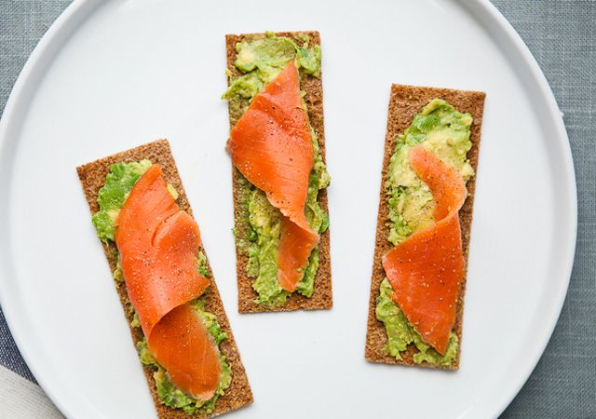
Smash ¼ of a ripe avocado and spread on 2-3 rye crackers. Top with 1 oz. smoked salmon, divided.

Lunch

Butternut Squash-Shiitake Ragout with Butter Lettuce Salad
Reheat 1½ cups leftover Butternut Squash-Shiitake Ragout in the microwave or in a small saucepan over medium-low heat (add a splash of water if it seems too thick). Serve alongside a salad of 4 cups butter lettuce and ¼ cup slivered radishes tossed with 1½ Tbsp. Smoky Lemon Tahini Dressing (see above).

Snack

Hard-Boiled Egg with Celery Salt
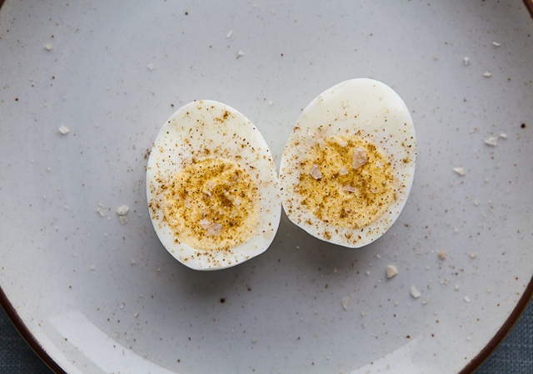

Dinner

Yogurt Chicken with Ginger-Coriander Chutney
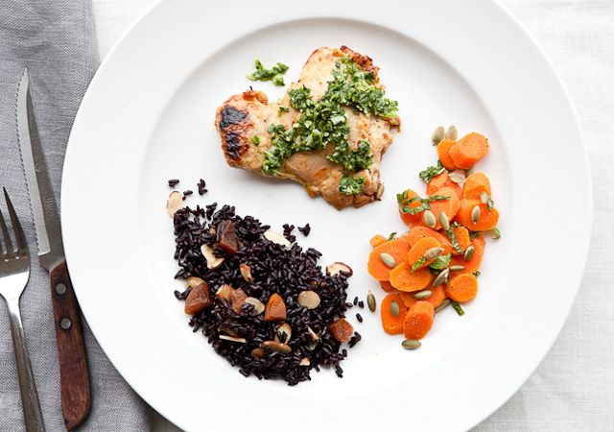
Click for recipe
For the Chicken:
- 1 garlic clove, grated
- 1 cup plain non fat Greek yogurt
- 2 tablespoons olive oil plus more for brushing
- ¼ teaspoon Hungarian hot paprika or cayenne pepper
- 1 teaspoon kosher salt
- 1 ½ pounds skinless, boneless chicken thighs, trimmed and each cut into 2-3 pieces
Whisk together garlic, yogurt, 2 Tbsp. oil, paprika, and salt in a large bowl. Add chicken; toss to coat with marinade. Cover and chill for at least 20 minutes and up to 1 day.
For the Chutney:
- 1bunch cilantro, chopped
- 1serrano chile, seeded, minced
- 1/4cupunsweetened flaked organic coconut
- 1 1/2tablespoonsfresh lemon juice
- 1tablespoonchopped peeled ginger
- 3/4teaspoonkosher salt
- Olive oil (for brushing)
Purée cilantro, chile, coconut, lemon juice, ginger, salt, and 1/4 cup water in a blender or food processor until smooth. Set aside.
Place a rack in middle of oven and another rack in top third of oven; preheat to 425°. Lightly brush a rimmed baking sheet with oil. Remove chicken from marinade, shaking off excess. Place in a single layer on prepared sheet.
Bake chicken on middle rack until cooked through, 10-15 minutes. Turn on broiler and move chicken to upper rack. Broil until tops of chicken pieces are browned in spots, about 3 minutes.

Black Rice with Apricots and Almonds
Click for recipe
- 1 cup black rice (preferably Lotus Foods Forbidden Rice)
- ¾ teaspoon kosher salt
- ¼ cup chopped dried apricots (preferably California apricots)
- ¼ cup chopped toasted almonds
Bring rice, salt, and 1 3/4 cups water to a boil in a medium saucepan. Reduce heat to low, cover, and cook until rice is tender, about 30 minutes. Fluff with a fork and let stand, covered, for 5 minutes. Stir in apricots and almonds.

Carrots with Mint
Click for recipe
- 3 large carrots, peeled, cut on a diagonal into 1/4' coins
- Kosher salt and freshly ground black pepper
- 2 tablespoons chopped fresh mint
- 2 tablespoons toasted pumpkin seeds (pepitas)
Bring carrots and 1/2 cup lightly salted water to a boil in a small pot. Reduce heat to medium-low, cover, and simmer until the carrots are crisp-tender, 7-9 minutes; drain. Season with salt and pepper. Add mint and pumpkin seeds.

Dessert

Salted, Seedy Chocolate Bark
1 serving

Day 4

Breakfast

Black Rice-Coconut Risotto
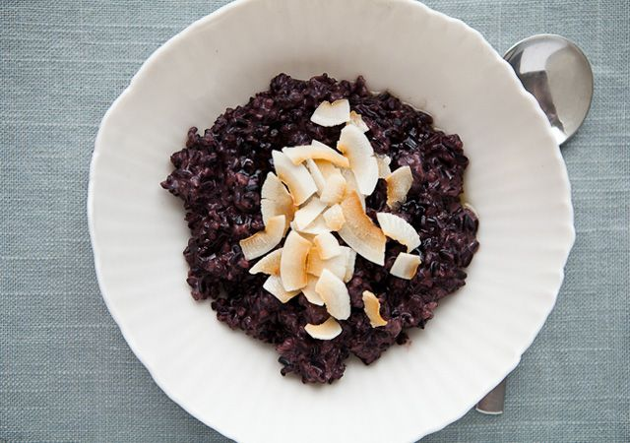
In a small saucepan, bring ½ cup cooked black rice (if you don’t have leftover rice, substitute ½ cup old-fashioned oats and add ¼ cup water and a pinch of salt to the pan) and ¾ cup unsweetened almond milk to a boil. Reduce heat and simmer until mixture is thick and porridge-like, about 15 minutes. Stir in 1 tsp. pure maple syrup and top with 1 Tbsp. unsweetened flaked organic coconut.

Lunch

Yogurt Chicken with Pineapple and Arugula
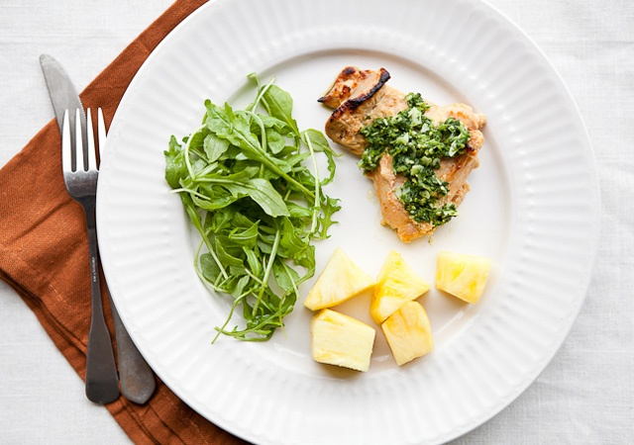
Reheat 4-6 oz. leftover Yogurt Chicken with Ginger-Coriander Chutney in the microwave. (It’s also good cold, if you prefer it that way.) Serve alongside 1 cup pineapple chunks and 3 cups arugula tossed with 1 Tbsp. Sherry Vinaigrette (see above).

Snack

Celery Sticks with Almond Butter and Smoked Paprika
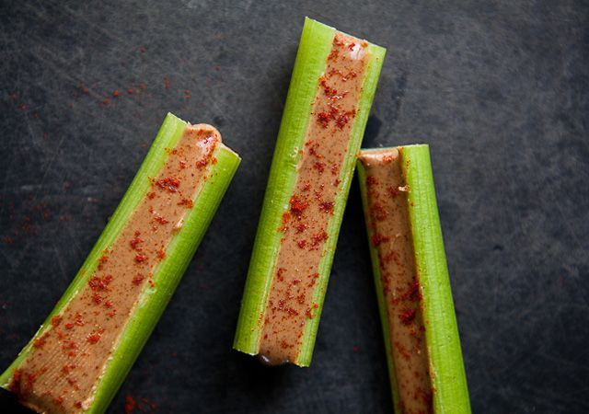
Spread 1 Tbsp. almond butter, divided, on 3-4 stalks celery. Sprinkle with a pinch of smoked paprika and a pinch of sea salt

Dinner

Sake-Steamed Clams with Soba Noodles
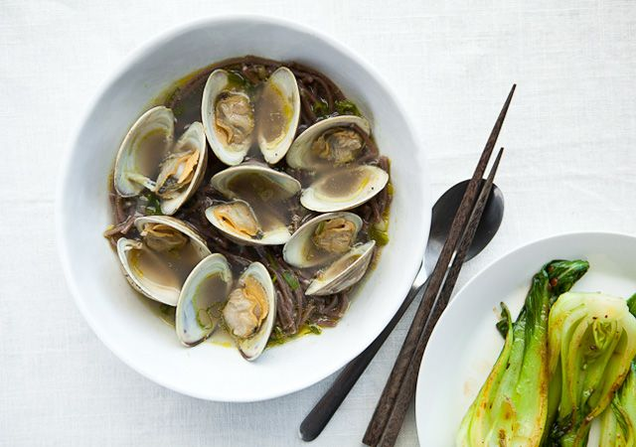
Click for recipe
- 8 ounces soba (Japanese-style) noodles
- Kosher salt
- 1 tablespoon vegetable oil
- 1 bunch scallions, white parts and dark-green parts separated, thinly sliced
- 1 jalapeño, seeded (unless you crave heat), sliced
- 1' piece of ginger, peeled, sliced
- 2 ½ pounds Manila clams, scrubbed
- ¾ cup dry sake
Cook soba noodles in a large pot of boiling salted water, stirring occasionally, until al dente. Drain and rinse in cold water.
Meanwhile, heat oil in a large skillet over medium-high heat. Add white parts of scallions, jalapeño, and ginger. Stir until aromatic, about 1 minute. Add clams; stir to coat and cook for 1 minute, then pour in sake. Cover and cook until clams open, 4—6 minutes (discard any clams that do not open). Using a slotted spoon, transfer clams to a bowl. Discard ginger slices.
Transfer noodles to the clam juices in skillet and cook for 1 minute to warm through. Divide noodles among bowls. Toss clams, along with the scallion greens, back into clam juices. Divide clams and broth evenly among bowls.

Bok Choy with Chili-Black Bean Paste
Click for recipe
- 1 tablespoon vegetable oil
- 1/2" piece ginger, peeled, minced
- 6 baby bok choy, trimmed, halved lengthwise
- 1 tablespoon chili paste with fermented black beans
- 1/2 teaspoon kosher salt
- 1 clove garlic
Heat oil in a large skillet over medium-high heat. Add ginger and garlic; stir until fragrant, about 30 seconds. Add bok choy and 1/4 cup water; immediately cover skillet. Cook, turning bok choy once, for 3 minutes. Stir in chili paste. Cook 1 minute longer, stirring occasionally; remove from heat and season with salt.

Dessert

Winter Citrus Salad
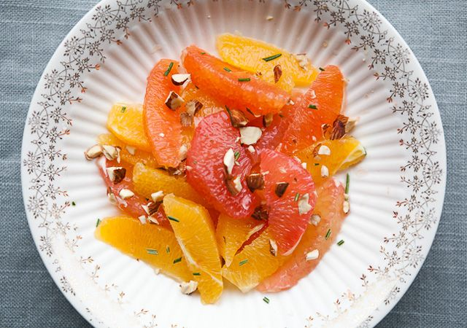
Cut peel and white pith from 2 navel oranges, 1 blood orange, and 1 pink grapefruit. Cut between membranes to release segments. Combine segments in a small bowl. Top with 1 Tbsp. chopped toasted almonds and ½ tsp. finely minced fresh rosemary.

Day 5

Breakfast

Omelet with Fresh Herbs and Goat Cheese
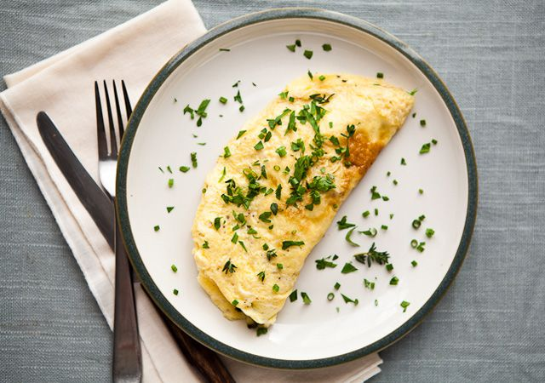
Make an omelet (or a scramble) with 2 eggs, 1 Tbsp. crumbled soft goat cheese, and assorted chopped herbs, such as parsley, tarragon, mint, and/or chives.

Lunch

Radicchio and Persimmon Salad with Hazelnuts and Goat Cheese
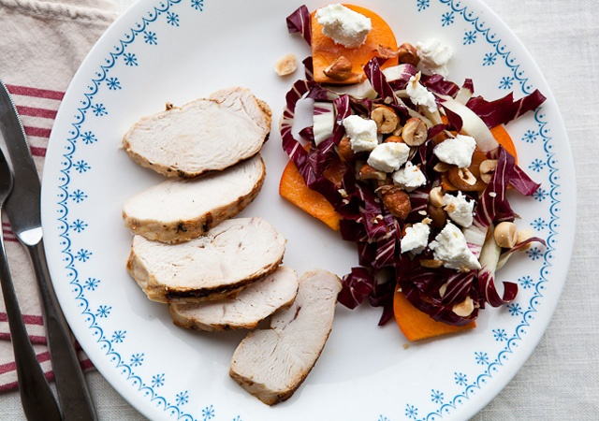
Toss 4 cups radicchio and 1 Fuyu persimmon (the flat variety), peeled, seeded, and cut into chunks, with 1½ Tbsp. Sherry Vinaigrette. Top with ½ oz. crumbled goat cheese and 2 Tbsp. toasted hazelnuts. You can substitute arugula, spinach, or a good dark salad mix for the radicchio, and use walnuts, pumpkin seeds, or sunflower seeds in place of the hazelnuts. If you didn’t find goat cheese, eat salad with purchased grilled chicken breast.

Snack

Mango Lassi
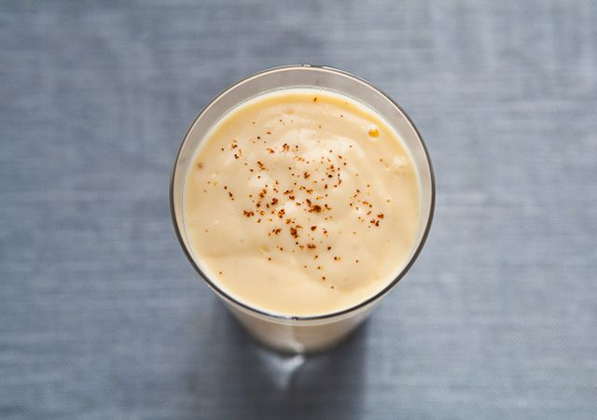
A dead-ripe fresh mango is more delicious than any frozen fruit. But if you can’t find one, use frozen mango, which will make a thicker, slushier shake. If your mango isn’t ripe, just add a squeeze of honey to the lassi.
To make, combine ¾ cup mango chunks (frozen or fresh and very ripe), ½ cup Greek yogurt, ¼-1/8; tsp. ancho chile powder, scant 1/8; tsp. salt (optional), and ¼ cup water in a blender; purée until smooth.

Dinner

White Bean Chili with Winter Vegetables
Click for recipe
- 1 tablespoon olive oil
- 2 leeks, white and 1' of pale-green part, diced
- 4 garlic cloves, finely chopped
- 2 large carrots, peeled, cut into 1/4' cubes
- 2 large or 3 medium parsnips, peeled, halved lengthwise if large (remove woody center, if needed), cut into 1/4' cubes
- 1–1 ½ tablespoons ground ancho chiles
- 1 teaspoon ground cumin
- ½ teaspoon dried oregano
- 2 teaspoons kosher salt plus more for seasoning
- 1 ¼ cups dried cannellini (white kidney) beans, soaked overnight (to yield about 3 cups) or two 15-oz. cans cannellini beans, rinsed
- Cilantro leaves (optional)
- 1 ripe avocado, peeled, chopped
Heat oil in a large pot over medium-low heat. Add leeks, garlic, and 2 Tbsp. water. Cook until leeks are softened, about 5 minutes. Add carrots and parsnips; stir to coat. Cook, stirring often, until just beginning to soften, about 2 minutes. Add ground chiles, cumin, oregano, and 2 tsp. salt. Stir until fragrant, about 1 minute. Fold in beans. Add 5 cups water and bring to a boil. Reduce heat and simmer to allow flavors to meld, about 30 minutes (if using soaked beans, cook until tender, which may take a few more minutes). Season with salt.
Garnish with cilantro leaves, if desired, and chopped avocado.
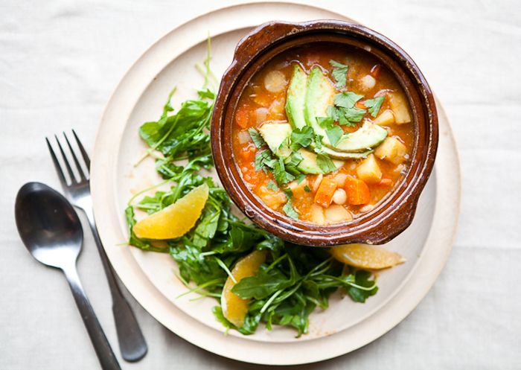

Arugula Salad with Orange Slices and Sherry Vinaigrette
2 cups of arugula per person, tossed with slices from one orange and 1Tbsp. of the sherry vinaigrette.

Dessert

One pear

Day 6

Breakfast

Orange Breakfast Bulgur with Pumpkin Seeds
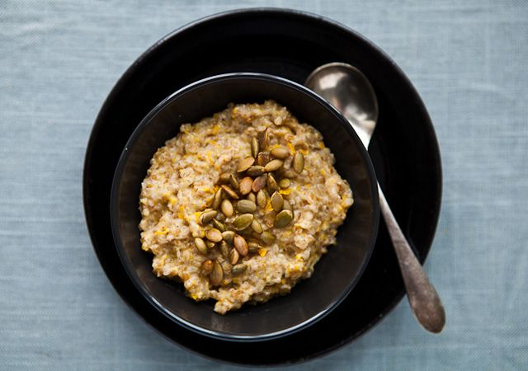
In a small saucepan, combine ½ cup plain cooked bulgur (if you don’t have leftover cooked bulgur, substitute ½ cup old-fashioned oats and add ¼ cup water and a pinch of salt to the pan), ½ cup unsweetened almond milk, 1 tsp. honey, and 1 tsp. finely grated orange zest; bring to a boil. Reduce heat and simmer until bulgur absorbs all liquid, about 10 minutes. Sprinkle with 1 Tbsp. toasted shelled pumpkin seeds (pepitas).

Lunch

White Bean Chili with Spinach and Pear Salad
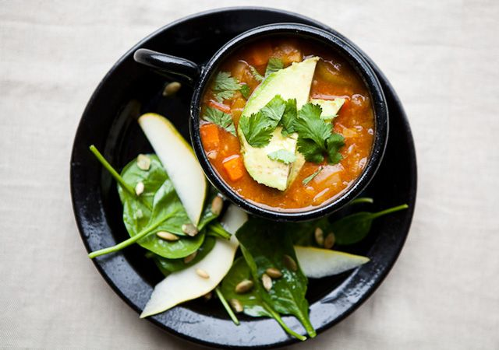
Reheat 1 ½ cups leftover White Bean Chili with Winter Vegetables. Toss 4 cups spinach and 1 small pear, cored and cut into ¼” slices, with up to 1 ½ Tbsp. Sherry Vinaigrette. Top with 2 Tbsp. toasted shelled pumpkin seeds (pepitas). If you don’t have leftovers, top salad with 1 hard-boiled egg and ¼ cup shelled edamame.

Snack

Applesauce and Hazelnuts
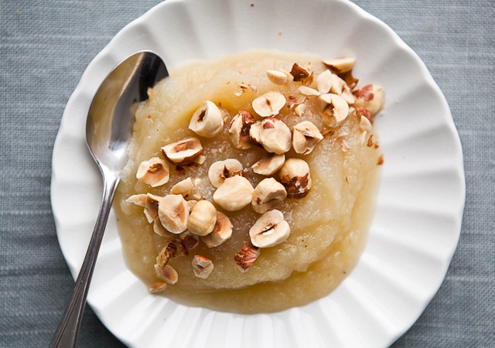
¾ cup applesauce and 10 toasted hazelnuts

Dinner

Confetti Lentils with Sockeye Salmon
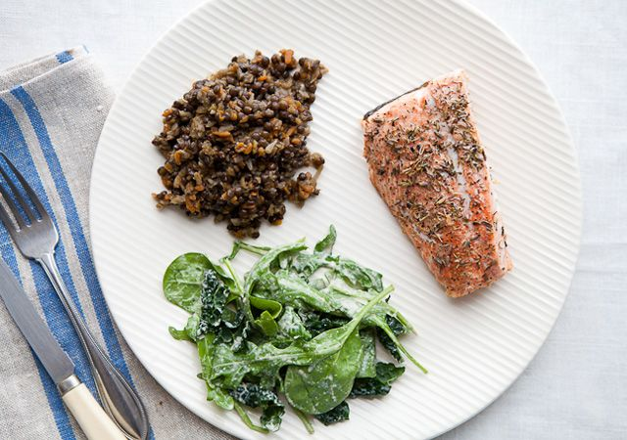
Click for recipe
Lentils
- 2 tablespoons olive oil
- 2 medium carrots, peeled, shredded on a box grater
- 1 medium celery root, peeled, shredded on box grater
- 1 medium onion, shredded on a box grater
- 2 teaspoons kosher salt plus more for seasoning
- 1¼ cups French green lentils
Heat oil in a large heavy pot over medium heat. Add carrots, celery root, onion, and 2 tsp. salt. Cook, stirring occasionally, until vegetables have softened, about 5 minutes. Stir in lentils. Pour in 3 3/4 cups boiling water and bring to a boil once more. Reduce heat to low and simmer, stirring occasionally, until lentils are tender but retain their shape, 20-30 minutes. Season with more salt, if desired. (Do not drain excess liquid; lentils remain tender better if stored in their cooking liquid.) To serve, use a slotted spoon or mesh strainer.
Salmon
- 46-oz. fillets wild sockeye salmon with skin
- ½ teaspoon kosher salt
- 1 tablespoon olive oil
Meanwhile, preheat oven to 350°. Season salmon fillets with salt. Heat oil in a large ovenproof skillet over medium-high heat. Place fillets, skin side down, in skillet. Cook until skin is crisp and lightly browned, then turn fillets over and place skillet in oven. Roast until salmon is just opaque in center, about 5 minutes.

Mixed Greens Salad with Smoky Lemon Tahini Dressing

Dessert

Salted, Seedy Chocolate Bark
1 oz. serving

Day 7

Breakfast

Tropical Fruit Salad with Almond Milk
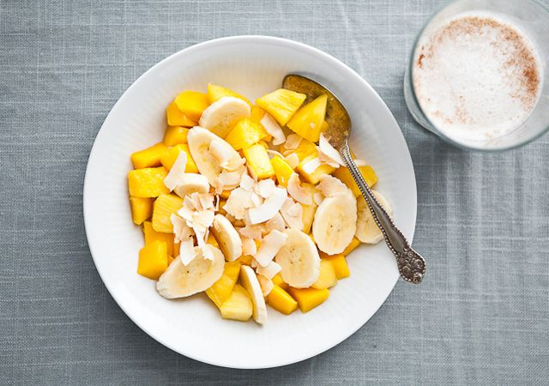
Mix ½ sliced banana, ½ cup fresh mango chunks, ½ cup pineapple chunks (fresh or unsweetened, canned), and 1 Tbsp. toasted unsweetened flaked organic coconut in a small bowl. Serve with a glass of unsweetened almond milk, dusted with ground cinnamon.

Lunch

Salmon with Kale, Radicchio, and Pomegranate Seeds
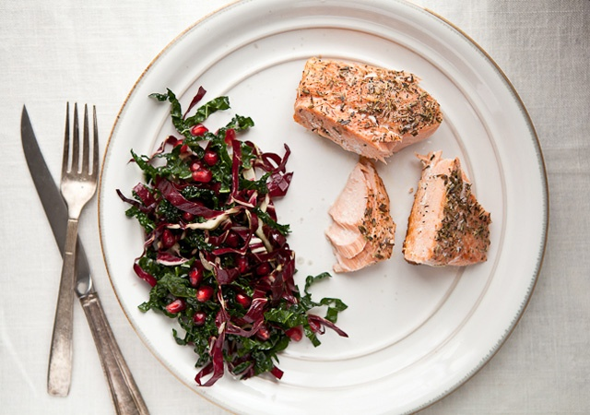
Crumble 3 oz. leftover salmon from Confetti Lentils with Sockeye Salmon into flakes; toss with 4 cups mixed radicchio and slivered kale and up to 1½ Tbsp. Sherry Vinaigrette. Top with 2-3 Tbsp. pomegranate seeds. You can substitute spinach or arugula or a good dark salad mix for the radicchio-kale mixture, and replace the pomegranate seeds with ¼ cup orange or tangerine segments. If you don’t have leftover salmon, swap in water-packed canned albacore tuna or 1-2 oz. smoked salmon.

Snack

Thin Rye Crackers with Almond Butter and Apple
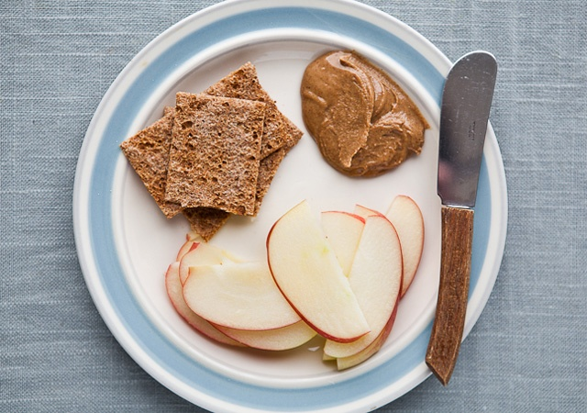
Spread 1 Tbsp. almond butter, divided, on 3 rye crackers.

Dinner

Tunisian-Style Poached Eggs in Red Pepper Sauce
Click for recipe
- 2 tablespoons olive oil
- 1 medium red onion, chopped
- 2 garlic cloves, finely chopped
- 4 red bell peppers, cored, cut lengthwise into 1/2”-wide strips
- 1 ½ teaspoons kosher salt, divided, plus more for seasoning
- 1 large tomato, cored, grated using the large holes on a box grater
- 1 tablespoon(or more) harissa paste
- 4 large eggs
- 1 teaspoon white wine vinegar or apple cider vinegar
- Flaky sea salt, such as Maldon
Heat oil in a large skillet over medium heat. Add onion and cook, stirring often, until softened, about 5 minutes. Add garlic; stir until fragrant, about 1 minute. Add peppers and 1 tsp. kosher salt and cook, stirring often, until peppers are wilted, 5—8 minutes. Add tomato, 1 Tbsp. harissa, and 1 cup water; reduce heat to medium-low and cook, stirring often and adding more water if too dry, until peppers are soft, 15—20 minutes. Season with kosher salt and more harissa, if desired. Keep warm.
Meanwhile, fill a large skillet with water. Add vinegar and 1/2 tsp. kosher salt; bring to a simmer. Crack each egg into a teacup, then slide each one into the water; reduce heat to low. Poach eggs until whites are set and yolks are gently set, 3—4 minutes.
Divide pepper sauce among four warm bowls and top each with an egg. Season egg with flaky sea salt.
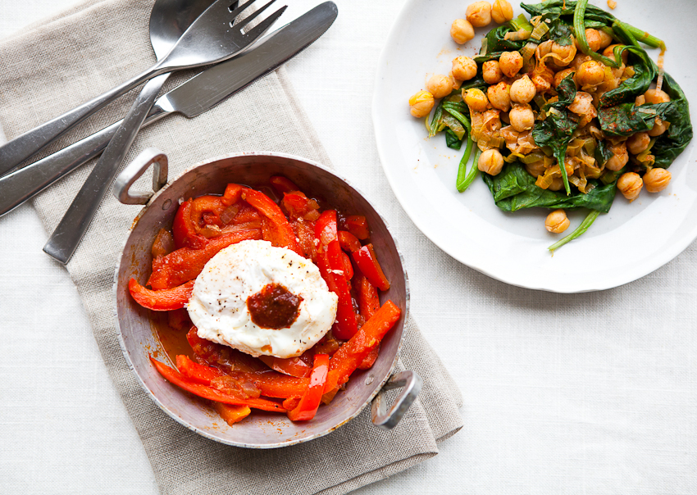

Chickpeas with Leeks, Spinach, and Smoked Paprika
Click for recipe
- 1 tablespoon olive oil
- 1 leek, white and light-green parts only, thinly sliced
- ½ teaspoon kosher salt plus more for seasoning
- 1 garlic clove, finely chopped
- 1 15-oz. can chickpeas, rinsed
- ½ teaspoon smoked paprika
- 1 bunch spinach, trimmed, thoroughly washed
Heat oil in a large skillet over medium heat. Add leek and 1/2 tsp. salt and cook until beginning to soften, about 3 minutes. Add garlic; stir for 1 minute. Add chickpeas and paprika and stir to coat. Add spinach and 2 Tbsp. water; cover skillet. Cook until spinach is wilted, about 2 minutes. Stir; season with salt.

Dessert

Two clementines

Day 8

Breakfast

Hot Multigrain Cereal with Blueberries, Almonds, and Sage
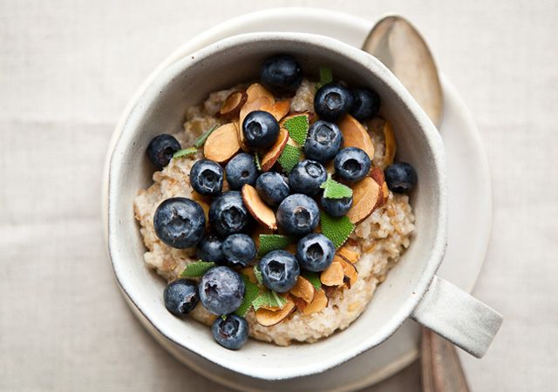
The flavor of sage is a beautiful complement to blueberries. Try sprinkling a little chopped sage over the berries in your morning oatmeal.
Cook ¼ cup ground hot cereal (such as Bob’s Red Mill 10 Grain Hot Cereal Mix) according to package directions; add ½ cup blueberries, 1-2 tsp. chopped toasted almonds, and ¼ tsp. chopped fresh sage (optional).

Lunch

Chickpeas and Greens with Arugula-Date Salad
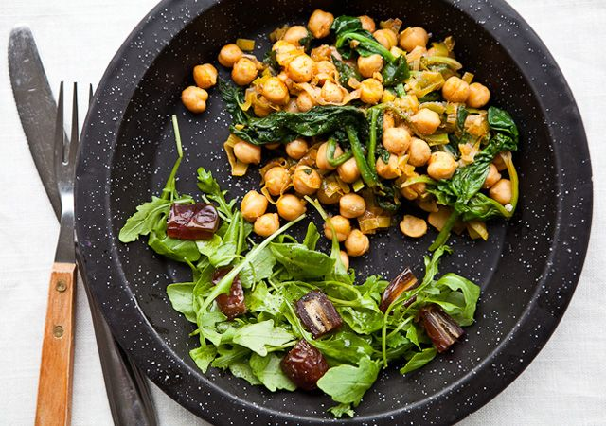
Warm 3/4-1 cup leftover Chickpeas with Leeks, Spinach, and Smoked Paprika. Serve alongside a salad of 2 cups arugula, 2 sliced pitted Medjool dates, and up to 1 Tbsp. Sherry Vinaigrette. If you don’t have leftovers, toss drained chickpeas or white beans into the salad instead.

Snack

Mango Lassi
See recipe above.

Dinner

Chicken Breasts with Cranberry Agrodolce
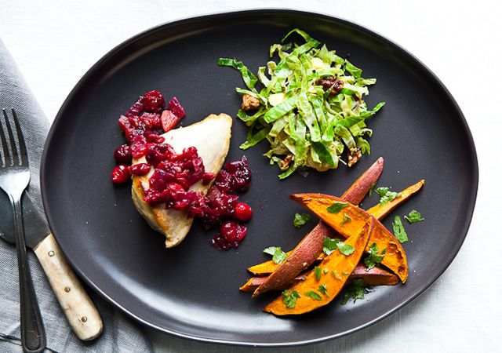
Click for recipe
Agrodolce
- 2 teaspoons vegetable oil
- 1 medium red onion, chopped
- Kosher salt
- 1 Granny Smith apple, peeled, cored, chopped
- 2 cups fresh (or frozen, thawed) cranberries
- 2 tablespoons pure maple syrup
- 1 tablespoon balsamic vinegar
Chicken
- 2 large bone-in, skin-on chicken breasts, each cut in half crosswise
- Kosher salt
- 1 garlic clove, minced
- 8 fresh sage leaves (optional)
- Freshly ground black pepper
- 1 teaspoon vegetable oil
Heat 2 tsp. oil over medium heat in a large saucepan. Add onion and a pinch of salt and cook, stirring occasionally, until the edges of the onion pieces become translucent, about 8 minutes. Stir in apple, cranberries, syrup, and vinegar. Increase heat to high and cook until cranberries begin to pop, about 5 minutes. Reduce heat to medium-low and cook until apples are soft, 8-10 minutes. Serve warm or at room temperature. DO AHEAD: Agrodolce can be made a day ahead. Cover and chill. Return to room temperature before serving.
Preheat oven to 425°. Loosen the skin on each piece of chicken, leaving it connected around the edges. Rub some salt and minced garlic under skin onto the breast meat. Tuck 2 sage leaves, if using, under skin of each piece of chicken. Season skin with salt and pepper.
Heat a large ovenproof skillet over medium-high heat. Brush pan with oil; lay chicken pieces, skin side down, in skillet. Cook until skin is golden brown, 7-8 minutes. Turn chicken pieces over and transfer to oven. Cook until meat is fully cooked, 15-18 minutes. Let rest for 5 minutes before serving topped with agrodolce.

Warm Brussels Sprout Slaw with Mustard Seeds and Walnuts
Click for recipe
- 1 tablespoon olive oil
- 2 tablespoons brown mustard seeds
- 2 large shallots, sliced
- ¾ teaspoon kosher salt, divided, plus more for seasoning
- 1 ½ pounds Brussels sprouts, trimmed, shredded
- 2 tablespoons fresh lemon juice
- ½ cup walnuts, toasted, chopped
Heat oil in a large skillet over medium-high heat. Add mustard seeds and cook, stirring frequently, until seeds begin to pop. Add shallots and 1/4 tsp. salt and toss to coat. Lower heat to medium and cook, stirring frequently, until lightly browned, 4 minutes. Add shredded Brussels sprouts and 1/2 tsp. salt and toss to coat. Pour in 1/3 cup water, reduce heat to medium, and cook until sprouts are crisp-tender, about 4 minutes. Stir in lemon juice and toss to coat. Season with more salt, if desired. Toss in walnuts and serve.

Sweet Potatoes with Jalapeño and Cilantro
Click for recipe
- 1 ½ pounds sweet potatoes, scrubbed, cut in 3/4” wedges
- 1 tablespoon olive oil
- ½ teaspoon kosher salt plus more for seasoning
- 3 tablespoons chopped cilantro leaves
- 2 teaspoons minced seeded jalapeño
- Juice of 1 lime
Preheat oven to 400°. Toss sweet potatoes with oil and ½ tsp. salt on a rimmed baking sheet; spread out in a single layer. Roast, turning once, until tender and lightly browned, 25—30 minutes.
Toss potatoes with cilantro, jalapeño, and lime juice. Season with more salt, if desired.

Dessert

Salted, Seedy Chocolate Bark
1 oz. serving

Day 9

Breakfast

Smoked Salmon and Avocado on Crisp Crackers
Smash ¼ of a ripe avocado and spread on 2-3 rye crackers. Top with 1 oz. smoked salmon, divided.

Lunch

Chicken and Frisée Salad with Sweet Potatoes
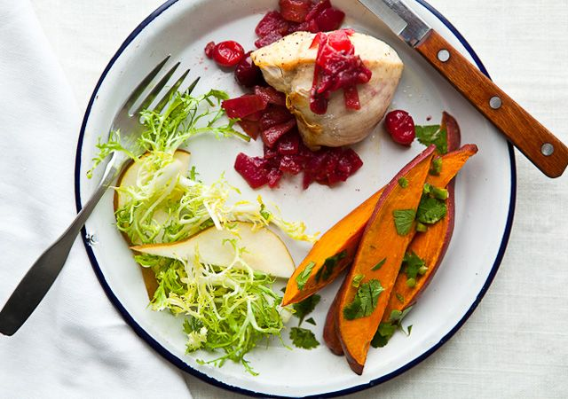
Toss 4 cups frisée and 1 Bosc pear, cored and sliced, with up to 1 Tbsp. Sherry Vinaigrette. Top with 1/3 cup leftover Sweet Potatoes with Jalapeño and Cilantro and 4 oz. leftover chicken from Chicken Breasts with Cranberry Agrodolce, serving a spoonful of the agrodolce alongside. (The chicken can be reheated in the microwave or served cold.) If you don’t have chicken leftover, use purchased grilled chicken breast and add 1 Tbsp. dried cranberries to the salad.

Snack

Almonds and Orange
10 toasted almonds and 1 navel orange

Dinner

Thai-Flavored Green Curry with Sweet Potato, Green Beans, and Chicken
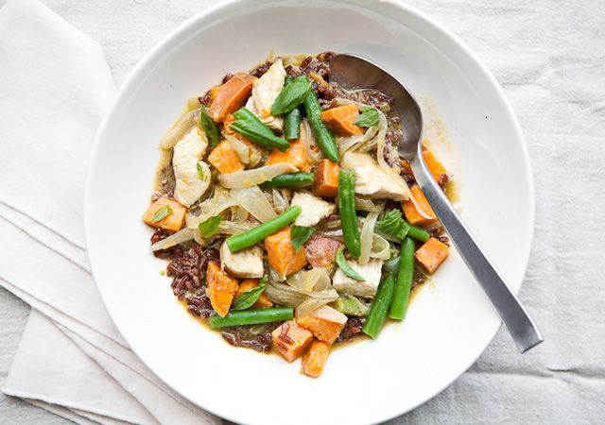
Click for recipe
- 1 tablespoon vegetable oil
- 1 medium onion, quartered, thinly sliced
- 2 tablespoons green Thai curry paste (preferably Thai and True brand)
- 1 cup canned unsweetened coconut milk
- 1 large sweet potato, scrubbed, quartered, cut into 1/2” chunks
- 3 cups trimmed green beans, cut in 2” pieces
- 1 large skinless, boneless chicken breast, cut in 1” pieces
- Kosher salt
- 20 basil leaves, preferably Thai (optional)
Heat oil in a large pot over medium heat. Add onion; cook, stirring often, until onion begins to soften, about 2 minutes. Add curry paste; stir for 1 minute. Whisk in coconut milk and 1 cup water. Add sweet potato and cook, uncovered, until sauce thickens to a creamy consistency, about 10 minutes. Stir in green beans, cover, and cook for 2 minutes. Fold chicken into mixture, cover, and cook until sweet potato is tender and chicken is just cooked through, about 4 minutes. Season with salt. Turn off heat and toss basil leaves, if using, into the curry.

Simple Red Rice
Click for recipe
- 1 cup Bhutanese red rice
- ½ teaspoonsalt
Rinse rice in cool water; drain. Bring rice, salt, and 1 1/2 cups water to a boil in a medium saucepan. Reduce heat to low, cover, and simmer until water is absorbed, about 20 minutes. Remove from heat. Fluff with a fork, re-cover, and let stand for 5 minutes before serving.
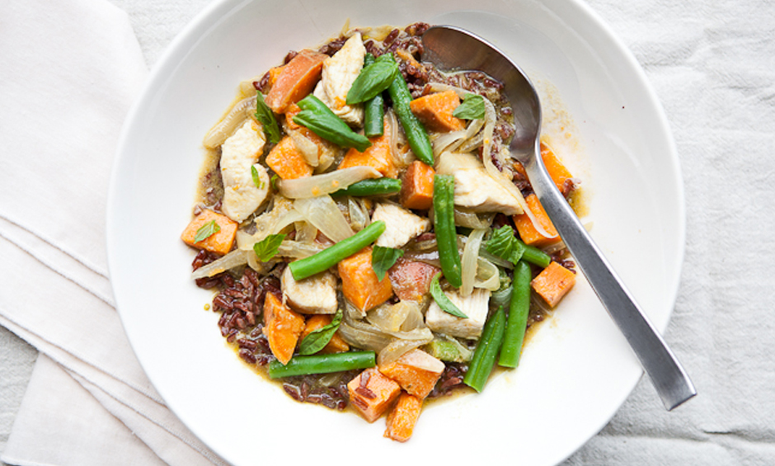

Dessert

Two clementines

Day 10

Breakfast

Pomegranate-Walnut Oatmeal
Cook oatmeal made with ½ cup dried old-fashioned oats (or ¼ cup steel-cut oats) according to package directions; top with ½ cup chopped fruit and 1 Tbsp. each chopped toasted walnuts and pomegranate seeds.

Lunch

Thai Curry with Pineapple
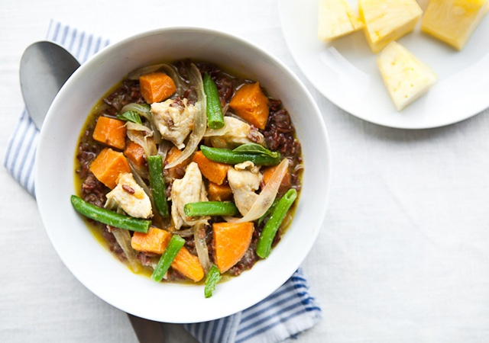
Reheat 1½ cups leftover Thai-Flavored Green Curry with Sweet Potato, Green Beans, and Chicken and 1 cup Simple Red Rice in the microwave. Serve alongside 1½ cups fresh pineapple chunks. If you don’t have leftovers, you could serve a quick salad of 4 cups spinach tossed with 1½ Tbsp. Smoky Lemon Tahini Dressing and topped with 1 hard-boiled egg and ¼ cup shelled edamame.

Snack

Apple-Blackberry Smoothie
Combine ¾ cup apple cider, ½ cup frozen blackberries, and &frac13; cup Greek yogurt in a blender; purée until smooth.

Dinner

Miso-Marinated Flank Steak

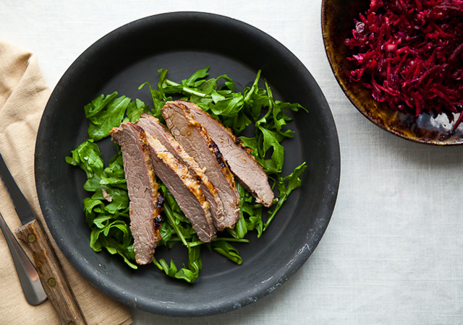
Click for recipe
- ¼ cup white miso (fermented soybean paste)
- 2 teaspoons Dijon mustard
- 1 teaspoon grated peeled ginger
- 1 teaspoon kosher salt
- 1 garlic clove, grated
- 2 tablespoons vegetable oil plus more for brushing
- 1 ½ pound grass-fed beef flank steak
- Flaky sea salt, such as Maldon, and freshly ground black pepper
Whisk together miso, mustard, ginger, kosher salt, garlic, and 2 Tbsp. oil into a paste. Smear on both sides of steak. Wrap well in plastic and chill for at least 30 minutes and up to overnight.
Arrange a rack in upper third of oven and preheat to 450°. Brush a baking sheet with oil. Remove steak from marinade, shaking off excess, and place on prepared sheet. Roast, turning once, until cooked to medium, about 13 minutes. Turn on broiler; cook steak, watching closely to prevent burning, until deep brown, about 1 minute per side. Let rest for 10 minutes. Thinly slice against the grain.

Purple Cabbage, Beet, and Apple Slaw
Click for recipe
- 1 shallot, finely chopped
- 1 teaspoon red or white wine vinegar
- 2 cups shredded red cabbage
- 1 large cooked beet, peeled, grated
- 1 large crisp apple (preferably Honeycrisp), grated (do not peel)
- ¼ cup dried cranberries
- 2 tablespoons Sherry Vinaigrette (see recipe)
- Juice of 1 lemon
Combine shallot and vinegar in a small bowl; let soak for at least 10 minutes.
Mix cabbage, beet, apple, cranberries, Sherry Vinaigrette, and macerated shallot in a large bowl. Season generously with lemon juice and salt.

Dessert

Salted, Seedy Chocolate Bark
1 oz. serving

Day 11

Breakfast

Fried Egg with Arugula and Chili Sauce
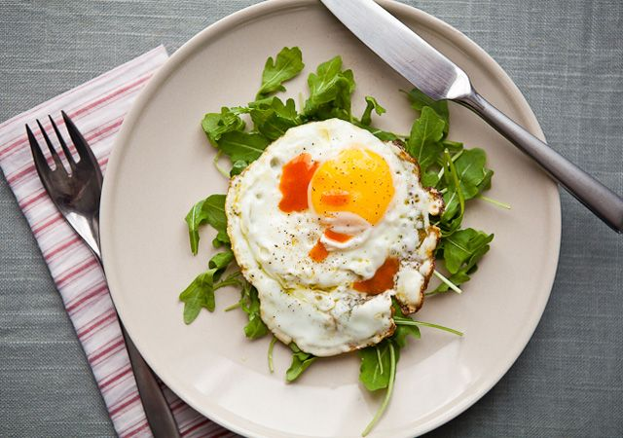
A little heat can be nice in the morning.
Serve one fried egg over some arugula; top with a little flaky sea salt and a drop or six of Sriracha (or harissa) chili sauce.

Lunch

Steak with Slivered Kale and Apples
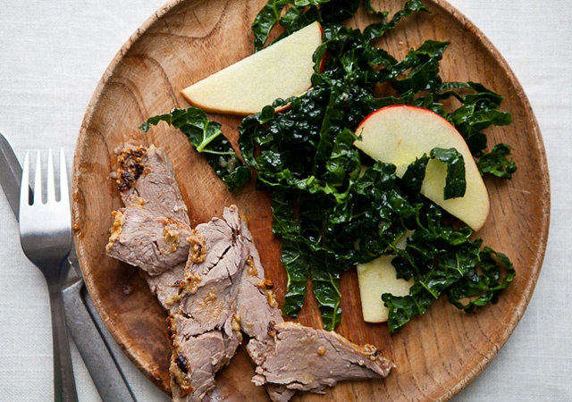
Toss 4-6 oz. leftover Miso-Marinated Flank Steak, sliced, with 4 cups slivered kale, 1 small apple, cored and cut into ¼” slices, and up to 1½ Tbsp. Sherry Vinaigrette. If you don’t have leftover meat, substitute tofu or chicken breast from the deli counter or the salad bar.

Snack

Avocado on Rye Crisp
Smash ¼ of a ripe avocado and spread on 2-3 rye crackers. Sprinkle with sea salt, lime juice, and crushed red chile flakes to taste.

Dinner

Vegetable Pot-au-Feu
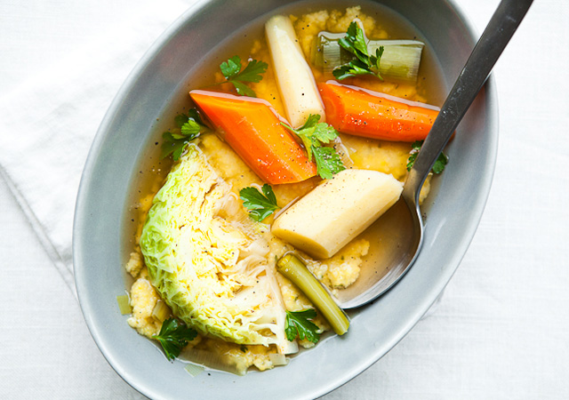
Click for recipe
- 2 large carrots, peeled, cut on a diagonal into 2” pieces
- 2 large leeks, white and light-green parts only, cut on a diagonal into 2” pieces
- 2 large or 3 medium parsnips, peeled, halved lengthwise if large (remove woody center, if needed), cut on a diagonal into 2” pieces
- ½ medium head of savoy cabbage, cut into 4 wedges, each with some core attached
- 2 flat-leaf parsley sprigs plus 1 tablespoon chopped for garnish
- 5 cups homemade chicken stock or low-sodium canned chicken broth
- Kosher salt and freshly ground black pepper
Place carrots, leeks, parsnips, cabbage, parsley sprigs, and stock in large heavy pot. Bring to a boil; reduce heat to low, cover, and simmer until vegetables are tender but not falling apart, about 20 minutes.
Season with salt and pepper.
Garnish with chopped parsley

Soft Thyme-Scented Polenta
Click for recipe
- 1 teaspoon salt plus more for seasoning
- 2/3 cup polenta (coarse cornmeal; not quick-cooking)
- 1 tablespoon fresh thyme leaves
- Freshly ground black pepper
- 1 peeled garlic clove, smashed
Bring 1 tsp. salt and 4 cups water to a boil in a medium saucepan. Whisk in polenta and thyme; return to a boil. Reduce heat to low and simmer, stirring occasionally, until polenta is soft, 25—30 minutes. Season with salt and pepper. Rub serving bowl with garlic clove before transferring polenta.

Dessert

One pear

Day 12

Breakfast

Raspberry-Hazelnut Muesli
Muesli is a cold porridge of fruit, nuts, and oats that you prepare the night before serving. In this case, the juices of clementines and frozen raspberries are blended with yogurt to make a soft pudding, which gets some toothsome texture the next morning from bits of toasted hazelnuts.
In a small bowl, mix ½ cup frozen raspberries, ½ cup old-fashioned oats, 1/3 cup unsweetened nonfat yogurt, ½ of a large apple (skin on, cored, shredded), fresh-squeezed juice of 1 clementine or ½ of a navel orange, and a pinch of salt in a small bowl. Cover and chill overnight. In the morning, sprinkle 1 Tbsp. chopped toasted hazelnuts over.

Lunch

Pot-au-Feu with Egg and Olives
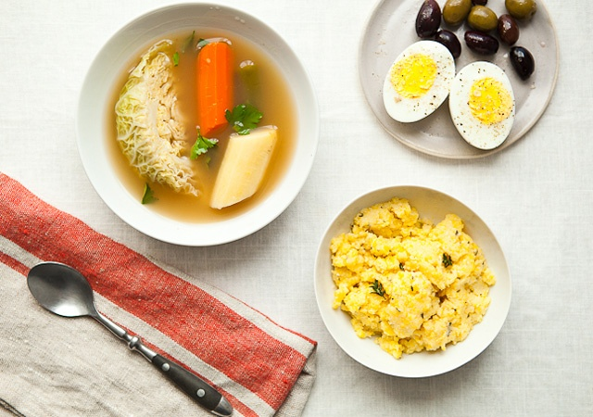
Reheat 1½ cups Vegetable Pot-au-Feu in the microwave or in a small saucepan over medium-low heat. Serve alongside 1 hard-boiled egg and 2 Tbsp. black olives. If you don’t have leftover Vegetable Pot-au-Feu, substitute a veggie-heavy salad, like slivered red cabbage, broccoli, and carrots tossed with 1½ Tbsp. Smoky Lemon Tahini Dressing.

Snack

Celery Sticks with Almond Butter and Smoked Paprika
Spread 1 Tbsp. almond butter, divided, on 3-4 stalks celery. Sprinkle with a pinch of smoked paprika and a pinch of sea salt.

Dinner

Coriander-Orange Pork Tenderloin
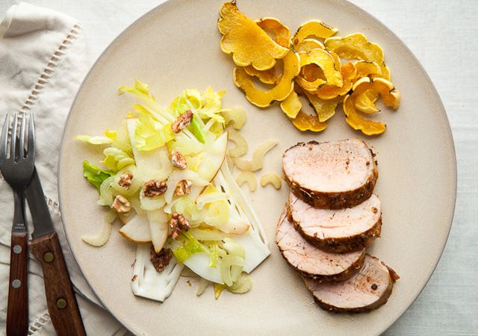
Click for recipe
- 1 tablespoon orange zest
- 2 teaspoons coriander seeds, crushed
- 1 teaspoon fine sea salt
- 1 teaspoon plus 1 tablespoon olive oil, divided
- 1 teaspoon paprika
- 11–1 1/4-lb. pork tenderloin, trimmed
Mix orange zest, coriander seeds, salt, oil, and paprika in a small bowl to make a thick paste. Rub all over pork. Let stand at room temperature for at least 20 minutes, or cover and chill up to overnight. Before cooking, let pork sit at room temperature for 20 minutes.
Preheat oven to 425°. Heat remaining 1 Tbsp. olive oil in a large ovenproof skillet over medium-high heat. Cook tenderloin, turning occasionally to thoroughly brown all over, 8-10 minutes. Transfer skillet to oven and cook until an instant-read thermometer inserted into center of tenderloin registers 140°, 5-10 minutes.

Shaved Vegetable and Walnut Salad
Click for recipe
- 2 large Belgian endive, very thinly sliced lengthwise
- 1 large Bosc pear, quartered, cored, very thinly sliced lengthwise
- 4—5 small inner stalks from celery heart, very thinly sliced crosswise, leaves reserved
- ¼ cup chopped toasted walnuts
- ¼ cup Sherry Vinaigrette (see recipe)
- Kosher salt and freshly ground black pepper
- Fresh lemon juice
Toss endive, pear, celery and leaves, and walnuts with Sherry Vinaigrette in a large bowl. Season with salt, pepper, and lemon juice.

Sage Roasted Squash
Click for recipe
- 1 ½ pounds Delicata squash, halved, seeded, sliced crosswise into 1/4' semicircles (do not peel)
- 2 tablespoons olive oil
- 1 teaspoon kosher salt
Preheat oven to 425°. Toss squash with olive oil and salt. Arrange in a single layer on a rimmed baking sheet and roast until squash is tender and lightly browned at the edges, 25–30 minutes.

Dessert

One navel orange

Day 13

Breakfast

Greek Yogurt with Dates, Sesame, and Toasted Quinoa
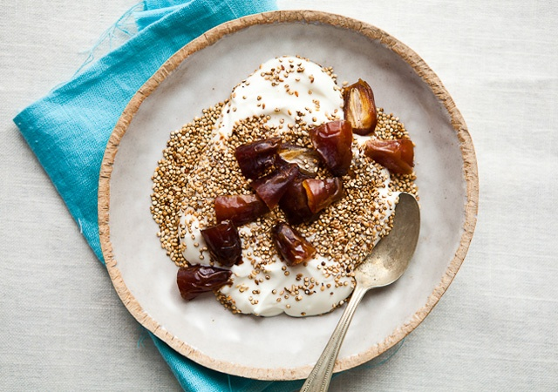
Here we take a tip from Seattle’s Sitka & Spruce, where the delicious house-made yogurt is topped with toasted quinoa. The toasting is easy to do, even early in the morning—and it’s a little exciting: As you toast the quinoa in a dry pan, it pops madly, like miniature popcorn.
Toast 1 Tbsp. uncooked quinoa and 1 tsp. sesame seeds in a dry skillet over medium-high heat, stirring constantly, until the quinoa darkens slightly, about 1½ minutes; let cool. Stir toasted mixture and 2 chopped pitted Medjool dates into ½ cup Greek yogurt.

Lunch

Pork with Spinach and Carrot Salad
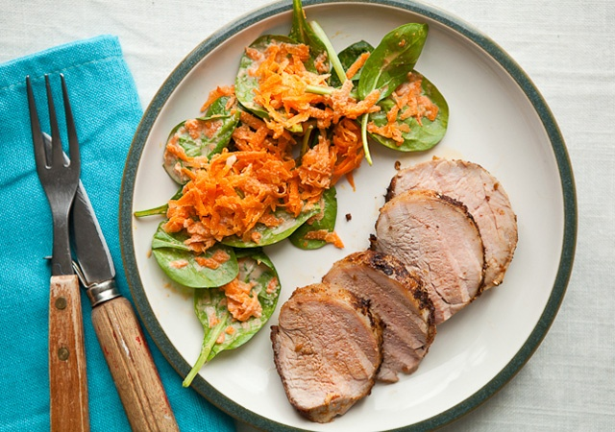
Serve 4-6 oz. leftover Coriander-Orange Pork Tenderloin (cold or reheated gently in the microwave), alongside ½ cup shredded carrots and 4 cups spinach tossed with up to 1½ Tbsp. Smoky Lemon Tahini Dressing. If you don’t have pork, toss canned water-packed albacore tuna or ¾ cup chickpeas with the salad.

Snack

Hard-Boiled Egg with Celery Salt

Dinner

Butternut Squash and Tomato Soup
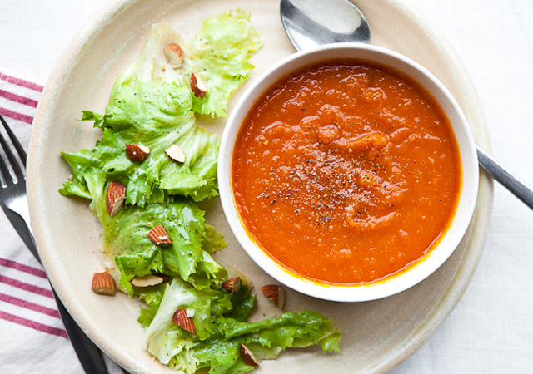
Click for recipe
- 2 tablespoons olive oil, divided
- 1 medium butternut squash, halved, seeded
- 2 garlic cloves, peeled
- 1 onion, chopped
- 2 teaspoons grated peeled ginger or 1/2 teaspoon dried ground ginger
- 2 teaspoons kosher salt plus more for seasoning
- ½ teaspoon ground turmeric
- 128-oz. can whole peeled tomatoes, drained
- 1 ½ cups low-sodium chicken broth
- Freshly ground black pepper
Preheat oven to 400°. Brush a baking sheet with 1 Tbsp. oil. Place squash halves, cut side down, on baking sheet and tuck a garlic clove under the hollow of each half. Roast until squash is tender all the way through, about 45 minutes. When cool, scoop out squash flesh and reserve, along with roasted garlic. Discard squash skins. DO AHEAD: Squash and garlic can be roasted 1 day ahead. Cover and chill.
Heat remaining 1 Tbsp. oil in a large heavy pot over medium heat. Add onion; cook until softened, about 5 minutes. Stir in ginger, 2 tsp. salt, and turmeric. Cook until fragrant, about 30 seconds. Add roasted squash and garlic cloves and stir to coat. Add tomatoes and chicken broth; bring to a boil. Reduce heat and simmer to allow flavors to meld, about 20 minutes.
Using an immersion blender, purée soup until smooth. (Alternatively, allow soup to cool slightly and purée in small batches in a blender.) Season with salt and pepper.

Escarole Salad
Click for recipe
- 1 small shallot, finely chopped
- 1 anchovy fillet packed in oil, chopped
- 3 tablespoons olive oil
- 1 tablespoon Sherry vinegar
- ¼ teaspoon Dijon mustard
- ¼ teaspoon kosher salt
- Pinch of freshly ground black pepper
- 1 head escarole, leaves torn (about 8 cups)
- 1 tablespoon chopped toasted almonds
Whisk shallot, anchovy, oil, vinegar, mustard, salt, and pepper in a large bowl. Add escarole and toss to coat. Garnish with almonds.

Dessert

One pear

Day 14

Breakfast

Hot Multigrain Cereal with Blueberries, Almonds, and Sage
The flavor of sage is a beautiful complement to blueberries. Try sprinkling a little chopped sage over the berries in your morning oatmeal.
Cook ¼ cup ground hot cereal (such as Bob’s Red Mill 10 Grain Hot Cereal Mix) according to package directions; add ½ cup blueberries, 1-2 tsp. chopped toasted almonds, and ¼ tsp. chopped fresh sage (optional).

Lunch

Butternut Squash and Tomato Soup with Avocado-Radicchio-Salmon Salad
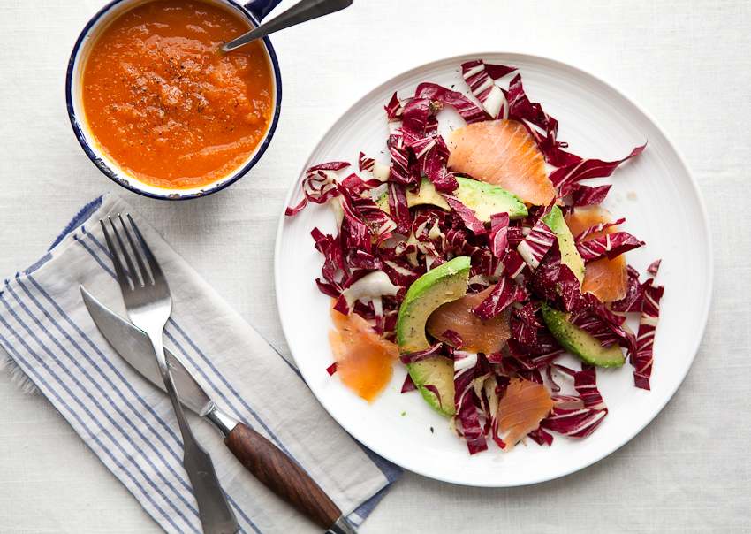
Reheat 1 cup Butternut Squash and Tomato Soup; serve alongside a salad of 3-4 cups slivered radicchio and ¾ diced ripe avocado tossed with 1½ Tbsp. Smoky Lemon Tahini Dressing. Top salad with 1-2 oz. smoked salmon slices. If you don’t have leftover soup, add some raw carrots, sliced thin or shredded, to the salad.

Snack

Walnuts and Pear
6-8 toasted walnut halves and 1 pear

Dinner

Charmoula-Rubbed Mahi-Mahi
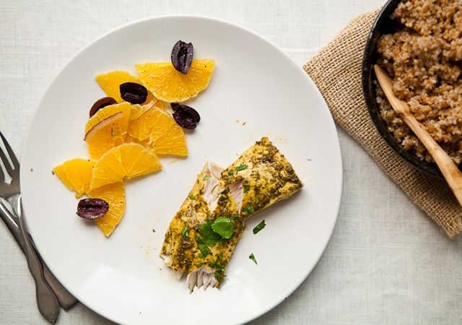
Click for recipe
- ½ cup finely chopped fresh cilantro
- ¼ cup olive oil
- ½ teaspoon ground cumin
- ½ teaspoon paprika, sweet or smoked
- ½ teaspoon kosher salt
- Juice of 1 lime
- 1 small garlic clove, grated
- 46-oz. mahi-mahi fillets
Stir together cilantro, oil, cumin, paprika, salt, lime juice, garlic, and 1 Tbsp. water (alternatively, pulse ingredients in a food processor for a smoother texture and a slightly more intense herbal flavor). Rub mixture onto the mahi-mahi fillets and chill for at least 15 minutes and up to 1 hour.
Preheat oven to 425°. Place marinated fish on a rimmed baking sheet. Roast until fish is just opaque in center, 10–15 minutes.

Shallot Bulgur
Click for recipe
- 1 tablespoon olive oil
- 2 shallots, finely chopped
- ¾ teaspoon kosher salt plus more to taste
- 1 cup fine bulgur
Heat oil in a small saucepan over medium heat. Add shallots and 3/4 tsp. salt. Cook, stirring occasionally, until shallots are quite soft and translucent, about 10 minutes. Add bulgur; stir to coat, then add 1 3/4 cups water. Bring to a boil; reduce heat to simmer, cover, and cook until bulgur is tender and all water is absorbed, about 15 minutes.

Olive and Orange Salad
Click for recipe
- ¼ red onion, thinly sliced
- 3 oranges, peel and white pith removed, halved lengthwise, cut in 1/4' semicircles
- ¼ cup thinly sliced Kalamata olives
- 1 tablespoon extra-virgin olive oil
- Tbsp. extra-virgin olive oil Flaky sea salt, such as Maldon, and freshly ground black pepper
Soak onion in cold water for 5 minutes; drain well. Press between double layers of paper towel to remove excess water (and some pungency). Toss onion, orange slices, olives, and olive oil in a medium bowl. Season with salt and pepper.

Dessert

Salted, Seedy Chocolate Bark
1 oz. serving

Day 1 2
Breakfast 2
Pomegranate-Walnut Oatmeal 2
Lunch 3
Kale Salad with Tuna and White Beans 3
Sherry Vinaigrette 3
Snack 4
Apple-Blackberry Smoothie 4
Dinner 5
Black Cod with Swiss Chard, Olives, and Lemon 5
Red Quinoa with Pistachios 6
Dessert 7
Salted, Seedy Chocolate Bark 7
Day 2 9
Breakfast 9
Raspberry-Hazelnut Muesli 9
Lunch 10
Pistachio Quinoa with Spinach and Egg 10
Smoky Lemon Tahini Dressing 10
Snack 11
Bosc Pear with Fresh Goat Cheese and Honey 11
Dinner 12
Butternut Squash-Shiitake Ragout 12
Bulgur with Parsley and Lemon Zest 13
Dessert 13
Two clementine’s 13
Day 3 14
Breakfast 14
Smoked Salmon and Avocado on Crisp Crackers 14
Lunch 15
Butternut Squash-Shiitake Ragout with Butter Lettuce Salad 15
Snack 16
Hard-Boiled Egg with Celery Salt 16
Dinner 17
Yogurt Chicken with Ginger-Coriander Chutney 17
Black Rice with Apricots and Almonds 18
Carrots with Mint 18
Dessert 18
Salted, Seedy Chocolate Bark 18
Day 4 19
Breakfast 19
Black Rice-Coconut Risotto 19
Lunch 20
Yogurt Chicken with Pineapple and Arugula 20
Snack 21
Celery Sticks with Almond Butter and Smoked Paprika 21
Dinner 22
Sake-Steamed Clams with Soba Noodles 22
Bok Choy with Chili-Black Bean Paste 23
Dessert 23
Winter Citrus Salad 23
Day 5 24
Breakfast 24
Omelet with Fresh Herbs and Goat Cheese 24
Lunch 25
Radicchio and Persimmon Salad with Hazelnuts and Goat Cheese 25
Snack 26
Mango Lassi 26
Dinner 26
White Bean Chili with Winter Vegetables 26
Arugula Salad with Orange Slices and Sherry Vinaigrette 27
Dessert 27
One pear 27
Day 6 28
Breakfast 28
Orange Breakfast Bulgur with Pumpkin Seeds 28
Lunch 29
White Bean Chili with Spinach and Pear Salad 29
Snack 30
Applesauce and Hazelnuts 30
Dinner 31
Confetti Lentils with Sockeye Salmon 31
Mixed Greens Salad with Smoky Lemon Tahini Dressing 32
Dessert 32
Salted, Seedy Chocolate Bark 32
Day 7 33
Breakfast 33
Tropical Fruit Salad with Almond Milk 33
Lunch 34
Salmon with Kale, Radicchio, and Pomegranate Seeds 34
Snack 35
Thin Rye Crackers with Almond Butter and Apple 35
Dinner 35
Tunisian-Style Poached Eggs in Red Pepper Sauce 35
Chickpeas with Leeks, Spinach, and Smoked Paprika 36
Dessert 37
Two clementines 37
Day 8 38
Breakfast 38
Hot Multigrain Cereal with Blueberries, Almonds, and Sage 38
Lunch 39
Chickpeas and Greens with Arugula-Date Salad 39
Snack 39
Mango Lassi 39
Dinner 40
Chicken Breasts with Cranberry Agrodolce 40
Warm Brussels Sprout Slaw with Mustard Seeds and Walnuts 41
Sweet Potatoes with Jalapeño and Cilantro 41
Dessert 42
Salted, Seedy Chocolate Bark 42
Day 9 43
Breakfast 43
Smoked Salmon and Avocado on Crisp Crackers 43
Lunch 44
Chicken and Frisée Salad with Sweet Potatoes 44
Snack 44
Almonds and Orange 44
Dinner 45
Thai-Flavored Green Curry with Sweet Potato, Green Beans, and Chicken 45
Simple Red Rice 46
Dessert 46
Two clementines 46
Day 10 47
Breakfast 47
Pomegranate-Walnut Oatmeal 47
Lunch 48
Thai Curry with Pineapple 48
Snack 49
Apple-Blackberry Smoothie 49
Dinner 50
Miso-Marinated Flank Steak 50
Purple Cabbage, Beet, and Apple Slaw 51
Dessert 51
Salted, Seedy Chocolate Bark 51
Day 11 52
Breakfast 52
Fried Egg with Arugula and Chili Sauce 52
Lunch 53
Steak with Slivered Kale and Apples 53
Snack 54
Avocado on Rye Crisp 54
Dinner 55
Vegetable Pot-au-Feu 55
Soft Thyme-Scented Polenta 56
Dessert 56
One pear 56
Day 12 57
Breakfast 57
Raspberry-Hazelnut Muesli 57
Lunch 58
Pot-au-Feu with Egg and Olives 58
Snack 59
Celery Sticks with Almond Butter and Smoked Paprika 59
Dinner 60
Coriander-Orange Pork Tenderloin 60
Shaved Vegetable and Walnut Salad 60
Sage Roasted Squash 61
Dessert 61
One navel orange 61
Day 13 62
Breakfast 62
Greek Yogurt with Dates, Sesame, and Toasted Quinoa 62
Lunch 63
Pork with Spinach and Carrot Salad 63
Snack 64
Hard-Boiled Egg with Celery Salt 64
Dinner 64
Butternut Squash and Tomato Soup 64
Escarole Salad 65
Dessert 65
One pear 65
Day 14 66
Breakfast 66
Hot Multigrain Cereal with Blueberries, Almonds, and Sage 66
Lunch 67
Butternut Squash and Tomato Soup with Avocado-Radicchio-Salmon Salad 67
Snack 67
Walnuts and Pear 67
Dinner 68
Charmoula-Rubbed Mahi-Mahi 68
Shallot Bulgur 68
Olive and Orange Salad 69
Dessert 69
Salted, Seedy Chocolate Bark 69

